Solutions for the Practice Mini Case

1. The dimensions in the problem are reasonably clear. Supplier, calendar, and product are dimensions. Supplier and product come from the ERD and the sample spreadsheet. The calendar dimension is a standard data warehouse dimension. Calendar is a hierarchical dimension. Phone and email can be parsed to be hierarchical as part of the supplier dimension.
- Supplier
  - SuppNo: ERD only
  - SuppName (Supplier table) | Supp (spreadsheet)
  - SuppPhone: ERD only; hierarchical (country code → area code → prefix → line)
  - SuppEmail: ERD only; hierarchical (top level domain → second level domain → local part)
- Calendar
  - Date columns in the ERD (ProdNextShipDate, PurchDelDate, and PurchDate) and spreadsheet (PurDate); hierarchical (year → month → day)
- Product:
  - ProdNo: ERD only
  - ProdName (ERD) | ProdDesc (spreadsheet)
  - ProdCode: spreadsheet only

2. The measures mostly come from the PurchLine table and supply purchases spreadsheet. Measures from related tables are important to associate with the measures from the PurchLine table and Supply Purchases spreadsheet.
- PLQty (PurchLine table) | Qty (spreadsheet); additive measure
- Amount of purchase: derived additive measure from the spreadsheet
- PLUnitCost (PuchLine table) | Unit Price (spreadsheet); snapshot measure
- ProdQOH (Product table) | Stock (Spreadsheet): Semi-additive across products but not useful to add quantity of different products. Usually average across time periods
- SuppDisc (Supplier table): supplier discount; snapshot measure
- ProdPrice: product price; snapshot measure indicating the standard sale price of the product when the purchase occurs

3. The most detailed grain is the combination of individual supplier, individual product, and date.
- 1,100 products: sum of product rows and unique products in a spreadsheet
- 120 suppliers: sum of supplier rows and unique suppliers in a spreadsheet
- Days per year: 365
- 512,000 purchases of individual products: sum of PurchLine rows and spreadsheet rows (one year)
- Fact table size is determined from sum of the rows in the PurchLine table and Spreadsheet. Thus, the individual product purchases per year are 512,000.
- Sparsity estimate:
  - 1 - ( fact table size / product of dimensions )
  - (1 – ( 512,000 / (1,100*120*365) ) = 0.98937
  - The data cube has mostly missing cells with slightly more than 1% of cells with non zero values.

4. The star schema should support the dimensions and measures specified in problems 1 and 2. There are two relationships between the Calendar and InvFact tables to record both the purchase and delivery dates. Product type is a new derived column indicating the data source (merchandise for resale or supply for internal usage). ProdNextShipDate was dropped in the data warehouse design. The problem did not indicate a clear usage the data warehouse. It could be added as another relationship from Calendar to InvFact if the date was useful for business intelligence reasoning. The relationship would be incomplete for the spreadsheet data source.

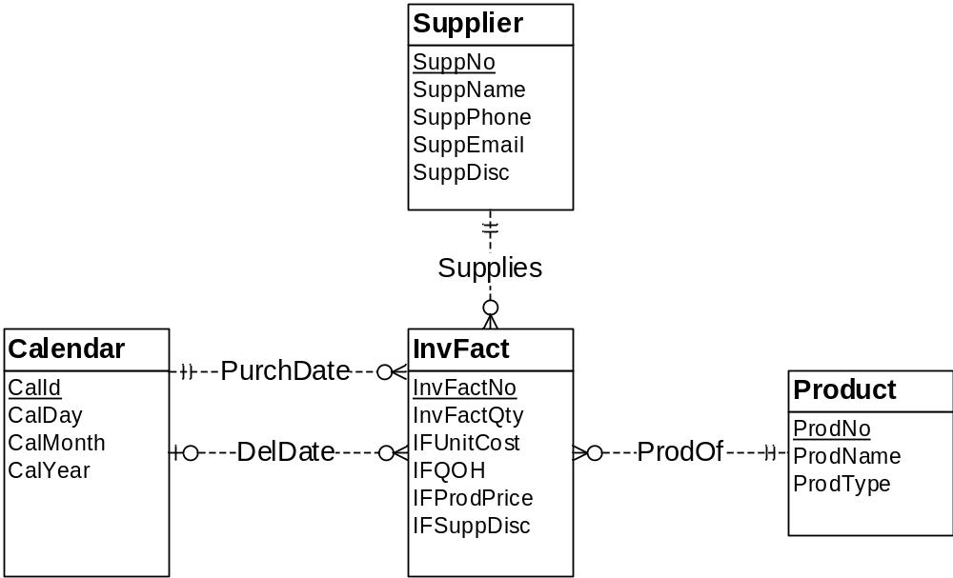

5. The DelDate relationship is an incomplete fact-dimension relationship as the delivery date is missing in the supply spreadsheet. It is probably not possible to add to existing data but second data source possibly can be changed in the future so delivery date is collected on the spreadsheet. If delivery date is the same as purchase date for supplies, the same date can be used as a default value.

There are also missing values for SuppEmail and SuppPhone for the suppliers from the spreadsheet. Although the Supplies relationship is mandatory, these missing values make the relationship missing for the SuppEmail and SuppPhone columns. Additional data collection can resolve this incompleteness as no reliable default value exists.

6. The data warehouse tables have been derived from the sample date in the source tables and spreadsheet. The delivery date for the supply purchases uses the default value of the purchase date since the values are missing the source data. New primary key values have been generated for data from the spreadsheet data source.

Sample Data for the Supplier Dimension Table
SuppNo | SuppName | SuppEmail | SuppPhone
S2029929 | ColorMeg, Inc. | custrel@colormeg.com | (720) 444-1231
S3399214 | Connex | help@connex.com | (206) 432-1142
S4290202 | Ethlite | ordering@ethlite.com | (303) 213-2234
S4298800 | Intersafe | orderdesk@intersafe.com | (512) 443-2215
S4420948 | UV Components | custserv@uvcomponents.com | (303) 321-0432
S5095332 | Cybercx | orderhelp@cybercx.com | (212) 324-5683
S1111111 | Omart
S1111112 | Smart
S1111113 | Pmart

Sample Data for the Product Dimension Table
ProdNo | ProdName | ProdType
P0036566 | 17 inch Color Monitor | Merch
P0036577 | 19 inch Color Monitor | Merch
P1114590 | R3000 Color Laser Printer | Merch
P1412138 | 10 Foot Printer Cable | Merch
P1445671 | 8-Outlet Surge Protector | Merch
P1556678 | CVP Ink Jet Color Printer | Merch
P3455443 | Color Ink Jet Cartridge | Merch
P4200344 | 36-Bit Color Scanner | Merch
P6677900 | Black Ink Jet Cartridge | Merch
P9995676 | Battery Back-up System | Merch
P111111 | No 2 pencils | Supp
P111112 | Copier paper | Supp
P111113 | File folders | Supp

Sample Data for the Calendar Dimension Table
CalId | CalDay | CalMonth | CalYear
C10000211 | 1 | 2 | 2019
C10000212 | 2 | 2 | 2019
C10000213 | 3 | 2 | 2019
C10000214 | 4 | 2 | 2019
C10000215 | 5 | 2 | 2019
C10000216 | 6 | 2 | 2019
C10000217 | 7 | 2 | 2019
C10000218 | 8 | 2 | 2019
C10000219 | 9 | 2 | 2019
C10000220 | 10 | 2 | 2019
C10000221 | 11 | 2 | 2019
C10000222 | 12 | 2 | 2019
C10000223 | 13 | 2 | 2019
C10000224 | 14 | 2 | 2019
C10000225 | 15 | 2 | 2019
C10000226 | 16 | 2 | 2019
C10000227 | 17 | 2 | 2019
Sample Data for the InvFact Measure Table (Part 1)
InvFactNo | ProdNo | SuppNo | IFQty | IFUnitCost | IFQOH | IFProdPrice | IFSuppDisc
I2224040 | P0036566 | S2029929 | 10 | $100.00 | 12 | $169.00 | 0.10
I2224041 | P0036577 | S2029929 | 10 | $200.00 | 10 | $319.00 | 0.10
I2224042 | P9995676 | S5095332 | 10 | $45.00 | 12 | $89.00 | 0.00
I2224043 | P1114590 | S3399214 | 15 | $450.00 | 5 | $699.00 | 0.12
I2224044 | P1556678 | S3399214 | 10 | $50.00 | 8 | $99.00 | 0.12
I2224045 | P3455443 | S3399214 | 25 | $21.95 | 24 | $38.00 | 0.12
I2224046 | P6677900 | S3399214 | 25 | $12.50 | 44 | $25.69 | 0.12
I2224047 | P1412138 | S4290202 | 50 | $6.50 | 100 | $12.00 | 0.05
I2224048 | P4200344 | S4420948 | 15 | $99.00 | 16 | $199.99 | 0.08
I2224049 | P111111 | S1111111 | 20 | $2.00 | 1
I2224050 | P111112 | S1111112 | 10 | $3.50 | 2
I2224051 | P111113 | S1111113 | 20 | $1.50 | 0

Sample Data for the InvFact Measure Table (Part 2)
InvFactNo | PurchCalNo | DelCalNo
I2224040 | C10000213 | C10000218
I2224041 | C10000213 | C10000218
I2224042 | C10000213 | C10000221
I2224043 | C10000214 | C10000219
I2224044 | C10000214 | C10000219
I2224045 | C10000214 | C10000219
I2224046 | C10000214 | C10000219
I2224047 | C10000213 | C10000218
I2224048 | C10000217 | C10000225
I2224049 | C10000223 | C10000223
I2224050 | C10000224 | C10000224
I2224051 | C10000221 | C10000221

